Directives in Angular
1.🔹 Angular Directives – Introduction
✅ What is a Directive?
A directive in Angular is a class with a @Directive decorator that allows you to manipulate the DOM or extend HTML behavior.
🔸 Types of Directives in Angular
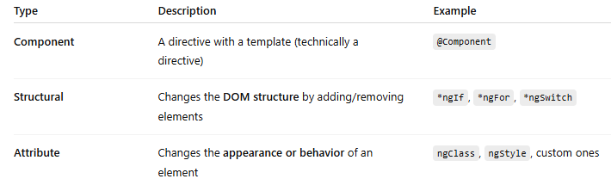
🔹 1. Structural Directive Example (*ngIf, *ngFor)
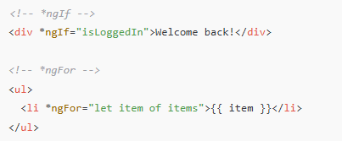
🔹 2. Attribute Directive Example (ngClass, ngStyle)
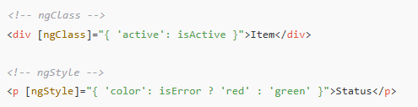

✅ Summary
Type | Directive | Role
Structural Directive | *ngIf | Add/remove DOM elements
Attribute Directive | ngClass | Apply CSS classes dynamically
Attribute Directive | ngStyle | Apply inline styles

